Boundary Umpire
Reports to: Field Umpire, Accountable to the Team Manager
Purpose of the role
- To umpire matches in accordance with the Laws of the Game
Qualifications & Desirable Characteristics
- Effective communication skills
- Organisational and time management skills
- Positive and enthusiastic
- Ability to make unbiased decisions.
Duties & Responsibilities
- Determining whether a football is out of bounds or out of bounds on the full and signalling to the field umpire when that has occurred.
- Throwing the football back into play if it has gone out of bounds when directed to do so by a field umpire.
- Determine whether a player has incorrectly entered the centre square (as indicated in the association/league rules and regulations)
- Bringing the football back to the centre square after a goal has been scored.
- Reporting a player or official who commits a reportable offence.

Penalty for failure to supply.
- A fine of 5 penalty units can apply should a club fail to provide a Boundary Umpire. RDFNL By-law 106

Practical application for parents

- This role requires running for up to 80 minutes with intermitted stopping and change of direction. In addition, you will be required to throw the football overhead.
- You need to arrive 20 mins before the game starts and remain available for the whole game.
- If it is your first time before the game starts go out to the centre and let the field umpire know as they can help you out if they know.
- You must wear a supplied white bib as defined by RDFNL By-law 115.
5-minute youtube clip that will help
https://www.youtube.com/watch?v=kAQz5Gqf1E4

Parent quick guide
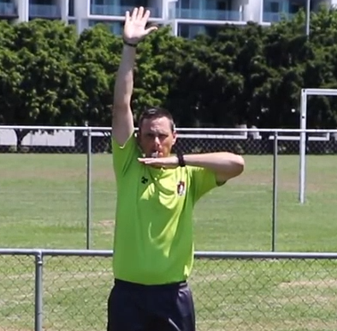
Out of Bounds – Ball is touched or rolls across the line. Once field umpire confirms you will throw the ball in.
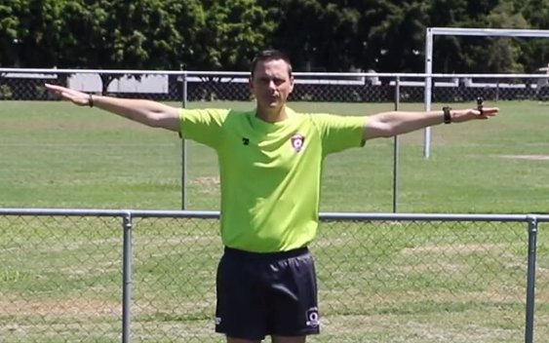
Out of Bounds on the full – Ball is kicked over the line. Ball will be kicked in by player.

