Goal Umpire
Reports to: Field Umpire, Accountable to the Team Manager

Purpose of the role
- The goal role is to umpire matches in accordance with the Laws of the Game

Qualifications & Desirable Characteristics
- Effective communication skills
- Organisational and time management skills
- Positive and enthusiastic
- Ability to make unbiased decision.

Duties & Responsibilities
- Determine whether a goal or behind has been scored.
- Signal that a goal or behind has been scored after being given all clear or touched all clear by a field umpire
- Record all goals and behinds scored by each team during a match.
- Report any player or official who commits a reportable offence, RDFNL By-law 71
- At the end of each quarter and at the end of each match, both goal umpires shall compare the score they have recorded.
- Liaise with all other umpires officiating in the match.

Practical application for parents

- This role requires standing, walking and use of arms above shoulder height.
- You need to arrive 20 mins before the game starts and remain available for the whole game.
- You need to be stand for up to 80 mins and walk to the centre of the ground between quarters.
- You must wear supplied white jacket as defined by RDFNL By-law 115.

Parent quick guide
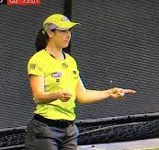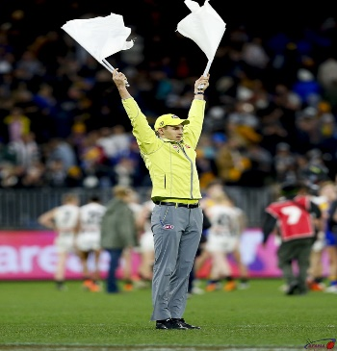
When the ball crosses through the goal without being touched by the opposition or touching the post. Use two fingers straight out in front to signal a gaol, then use a flag to signal the goal umpire at the other end.
If the ball is touched by a player or hits the post it is signalled as a point and the signals below are used to indicate that it touched the goal post or was touched by a player.
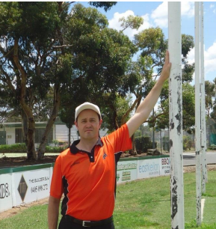
Hit post Ball touched before crossing line

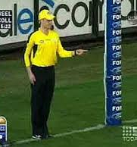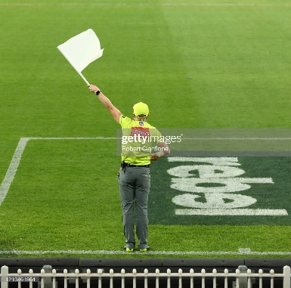
A point is signalled with a single finger and one flag after the all-clear from the field umpire.

If the ball hits the point post it is considered out of bounds and the boundary umpire will through the ball in.
